Copy of BCC Logo **Belmont City College 2023**

**Year 12 ATAR Human Biology Unit 3**

**Task 2 Part A: Test – Endocrine System**

Name: Marking Key **Total Mark /40**

**Section One: Multiple Choice (10 Marks)**

Place a cross (X) through the selected letter:  
  
1. A B C D 6. A B C D

2. A B C D 7. A B C D

3. A B C D 8. A B C D

4. A B C D 9. A B C D

5. A B C D 10. A B C D

**Section Two: Short Answer (20 Marks)**

**Question 11 (15 marks)**

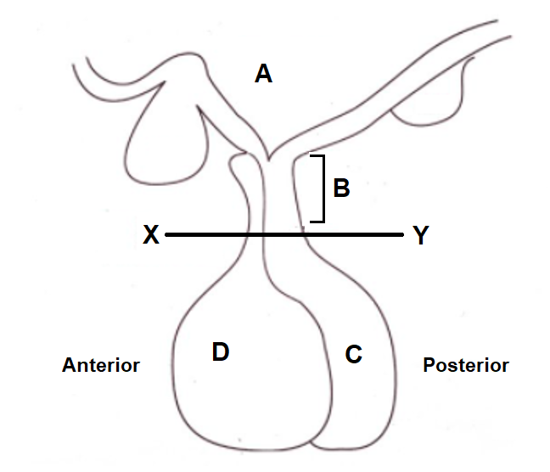Refer to the diagram below and answer the questions that follow.

1. The structure labelled ‘B’ is the ……**Infundibulum**………………... (1 mark)
2. If a cut is made at line XY, what effect will this have on the function of ‘C’? (1 mark)

**C will no longer be able to release ADH and Oxytocin (do not accept “no longer able to make” hormones)**

1. Explain why the cut resulted in this effect. (2 marks)

**Nerve fibres from the hypothalamus are severed (1) so hormones cannot pass down to the posterior pituitary (1)**

1. Explain the effect that this will have on the kidneys. (1 mark)

**Kidneys will retain less water / make more dilute urine**

1. Explain the different methods ‘A’ uses to stimulate parts C and D, so they can release their respective chemicals. (4 marks)

**‘A’ (the hypothalamus) produces releasing factors (1) that travel to D (anterior pituitary) via the blood vessels of the infundibulum (1)**

**‘A’ (the hypothalamus) produces hormones (1) that travel to C (posterior pituitary) via nerve fibres in the infundibulum (1)**

1. Discuss in detail how the structure labelled D in the diagram above assists in regulating Basal Metabolic Rate. (6 marks)

**D is the Anterior Pituitary. It responds to Thyrotropin Releasing Factor (TRF) (1) produced by the Hypothalamus (1).   
  
The TRF stimulates the Anterior Pituitary to produce Thyroid Stimulating Hormone (TSH) (1) and release it into systemic circulation.   
  
TSH binds to specific receptors on the thyroid gland (1), stimulating it to release Thyroxine (1) into the systemic circulation.   
  
Thyroxine binds to receptors on most body cells, which respond by increasing Basal Metabolic Rate (1)**

**Question 12 (5 marks)**

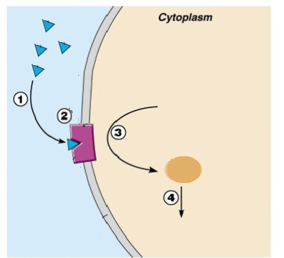

Using the diagram above, complete the following questions:

1. At point 2, why is this hormone able to bind, but not other hormones? (1 mark)

**The receptor is specific for the hormone involved. Other hormones will not be able to bind.**

1. Describe what is occurring at points 1-4. (4 marks)

|  |  |
| --- | --- |
| 1 | Hormones in extracellular fluid |
| 2 | Hormone binds to receptor on cell membrane |
| 3 | Second Messenger Activated |
| 4 | Second Messenger has effects within the cell |

**Section Three: Extended Answer**

**Question 13 (10 marks)**

After fasting for a period of time, blood glucose levels fall. Describe the hormonal process involving the pancreas that brings blood glucose back to homeostatic levels, and what happens once the homeostatic set point is reached. (10 marks)

Any 10 of:

**Falling blood glucose levels detected by alpha cells (1) of pancreatic islets (1)**

**Alpha cells stimulated to release glucagon (1)**

**Glucagon stimulates the liver (1) to convert glycogen to glucose (1) in a process called glycogenolysis (1)**

**The liver releases glucose into the blood stream (1)**

**Blood glucose levels rise (1)**

**Once blood glucose levels reach homeostatic levels the alpha cells are no longer stimulated (1), stopping further release of glucagon (1) via negative feedback (1)**

**END OF TEST PAPER**